DSC 530 Weeks 1 & 2 Discussion/Participation
- Divide up the 20 posts due at the end of each bi-week over at least 4 days.
Weeks 1 & 2 – 2025-12-11,12,13,14 (assignment due 15)

- What is exploratory data analysis and how would you explain it to someone new to data science?
- What is Python? What can it be used for outside of data science? Provide some real-life use cases and business problems being solved by Python.
- How would a data scientist choose which programming language to use to conduct EDA? Are you familiar with R or another language, and what are the pros and cons of each language that you may use for EDA?
- What is data quality and how important do you think it is for data analysis? Are there any tools that allow data scientists to conduct quality checks of their data? What are the guidelines data scientists use to check data quality?
- Find a recent article(s) or use case that discusses the different challenges associated with maintaining data quality for data analytics workflow. Share examples that resonate with your current experience in professional work or other analytical projects and discuss what are the approaches taken to address data quality issues.
- What are the overlaps between data science, data reporting, and business analytics? Is data science just a buzz word or is there a fundamental difference between the areas?
- What are the different ways to collect data? What are the methods you have tried to collect data and what are some steps you have taken to clean the data for the analysis you designed to do?

What is Python? What can it be used for outside of data science? Provide some real-life use cases and business problems being solved by Python.

Python is a coding language that is very versatile in nature. It can be used in a wide variety of useful ways, outside of data science. For example, for systematic reviews and meta-analysis papers, a simple python script can be written to deduplicate the search results from different database searches. If you develop a search strategy to find all possible literature regarding a specific topic for your systematic review paper, and you use more than one database—as you should—then you will undoubtably, again, as you should, retrieve duplicate records and reports. There are reference management software and tools (e.g., Zotero, Mendeley, etc.) to help automate this step, but as it stands, they produce unreliable results from deduplication, and is often even easier to go through all results manually. Now, this doesn’t imply that it actually is easy. I say this to denote the notion that in this particular step of the systematic review workflow, there is no “de facto” or “gold-standard” method to produce reliable and accurate results.
This is where python comes in. As mentioned previously, this python script not only allows you to pick specific attributes (columns – such as DOI, title, author names, etc.) by which to deduplicate but produces a mermaid flowchart to show exactly how many duplicates were found and removed. These numbers are crucial for accurate reporting according to PRISMA guidelines.

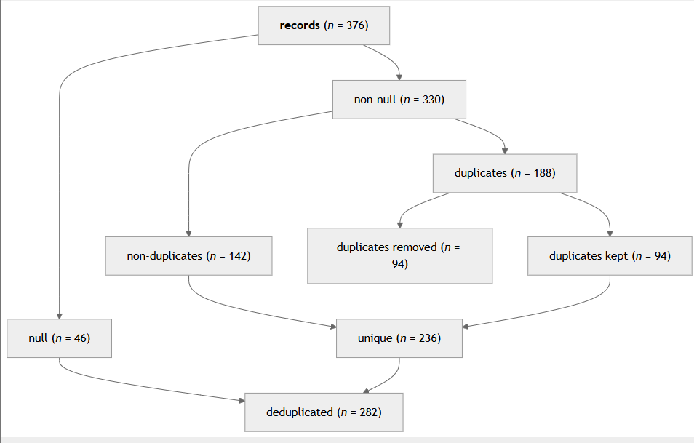

What are the different ways to collect data? What are the methods you have tried to collect data and what are some steps you have taken to clean the data for the analysis you designed to do?

There are many different ways to collect data, but the most standardized way is to develop a data entry form that is piloted (tested) for use in data collection. This allows simple and standardized way to collect data in a way that is reportable and reproducible. Two key pillars in data collection in systematic reviews and meta-analysis papers, where I have had my personal and professional experience in data analysis. Not only are the use of data entry forms mandatory according to Cochrane guidelines, they facilitate an environment for collaboration amongst research team members to stay on track together. Furthermore, aside from creation of a workflow that is conducive to reproducible and transparent reporting, data collection—by way of forms—allows comparison of data collection results by multiple independent reviewers with the use of intraclass correlation coefficient (or ICC). Data cleaning is made simple by structuring the data collection workflow before you start, not during or after (ad-hoc, post-hoc, respectively).

